MODELAGEM VISUAL PLANTA MECATRIME
Versão 02
Revisão 2021-05-26

Sumário
Diagramas de blocos gerais 2
Diagramas de atividades 8
Máquinas de estados 9
Mensagens do Manager 9
Subrotinas do Scorbase 10
Variáveis de memória do Scorbase 20
Jobs FS-100 21
Variáveis de memória FS-100 29
Componentes físicos 30
Executores / Processadores 35

Diagramas de blocos gerais
MODELAGEM VISUAL - Arquivo: VISUAL MODELING - v02.graphml

DIAGRAMA DE BLOCOS FÍSICOS – Arquivo: PHYSICAL BLOCK DIAGRAM - v02.graphml

DIAGRAMA DE CONEXÕES FÍSICAS – Arquivo: PHYSICAL CONNECTIONS DIAGRAM - v02.graphml

DIAGRAMA DE BLOCOS CIBERNÉTICOS – Arquivo: CYBERNETIC BLOCK DIAGRAM - v02

DIAGRAMA DE CONEXÕES CIBERNÉTICAS – Arquivo: CYBERNETIC CONNECTIONS DIAGRAM - v02.graphml

CYBERPHYSICAL CONNECTIONS DIAGRAM – Arquivo: CIBERPHYSICAL CONNECTIONS DIAGRAM - v02.graphml

Diagramas de atividades
ACTIVITY DIAGRAM – Arquivo: ACTIVITY DIAGRAM - v02.graphml

Máquinas de estados

Mensagens do Manager
MANAGER MESSAGES – Arquivo: MANAGER MESSAGES - v02.graphml

Subrotinas do Scorbase
SUBROUTINE GET023
Set Subroutine GET023  Print to Screen: GET FROM Gravity Feeder  Call Subroutine SCRIPT.GET_FROM_GFDR1  Print to Screen: P1,P2, PB1: 'SCRIPT.P1', 'SCRIPT.P2' , 'SCRIPT.PB1'  Print to Screen: P3,P4, P5: 'SCRIPT.P3', 'SCRIPT.P4' , 'SCRIPT.P5'  Copy FS100 Position SCRIPT.P1 to Position 1001  Copy FS100 Position SCRIPT.P2 to Position 1002  Copy FS100 Position SCRIPT.P3 to Position 1003  Copy FS100 Position SCRIPT.P4 to Position 1004  Go to Position SCRIPT.PB1 Speed 50 (%)  FS100 Start Job GT023  Wait FS100_DELAY_TIME (10ths of seconds)  FS100 Job Wait 60 (seconds)  Send Message $Start to MANAGER ID=TASK_ID  Return from Subroutine | 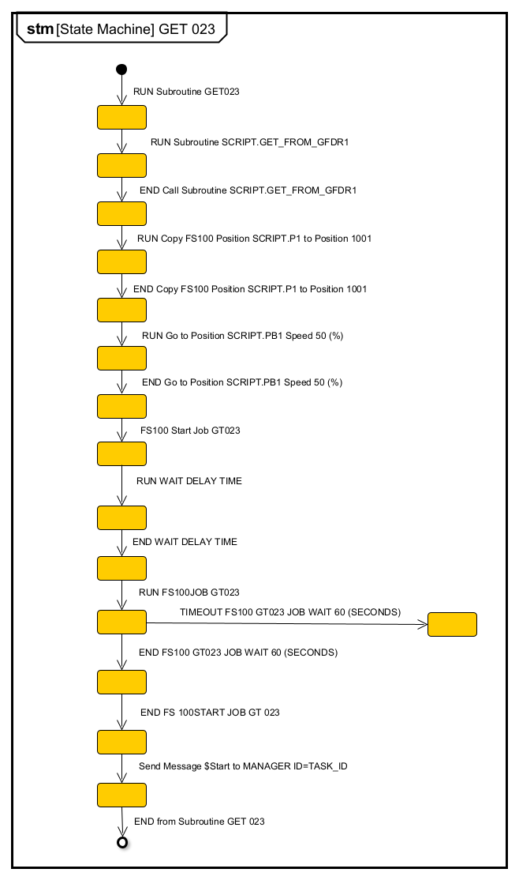

SUBROUTINE PUT022
Set Subroutine PUT022  Print to Screen: Place on Lathe (CONCEPT 250)  Run Subroutine PREPARE_LATHE_LOAD  Call Subroutine SCRIPT.PUT_TO_LATHE1  Print to Screen: P1,P2,P3, P4: 'SCRIPT.P1', 'SCRIPT.P2' , 'SCRIPT.P3' ,'SCRIPT.P4'  Print to Screen: PB1,PB2: 'SCRIPT.PB1', 'SCRIPT.PB2'  Go to Position SCRIPT.PB1 Speed 50 (%)  LATHE_READY_TO_LOAD:  Wait 1 (10ths of seconds)  If LATHE_LOAD==0 Jump to LATHE_READY_TO_LOAD  Copy FS100 Position SCRIPT.P1 to Position 1001  Copy FS100 Position SCRIPT.P2 to Position 1002  Copy FS100 Position SCRIPT.P3 to Position 1003  Copy FS100 Position SCRIPT.P4 to Position 1004  FS100 Start Job PT022  Wait 10 (10ths of seconds)  FS100 Job Wait 60 (seconds)  Call Subroutine CLOSE_LATHE_DOOR  Send Message $Finish to MANAGER ID=TASK_ID  Go to Position SCRIPT.PB2 Speed 50 (%)  Send Message $End to MANAGER ID=TASK_ID  Return from Subroutine  Call Subroutine  Enter the name of a subroutine that will be executed in case of interrupt. Execution of the main program is suspended until completion of the subroutine.  Run Subroutine  Enter the name of a subroutine that will be executed in case of interrupt. Execution of the main program continues, and the subroutine is spawned as a concurrent process. | 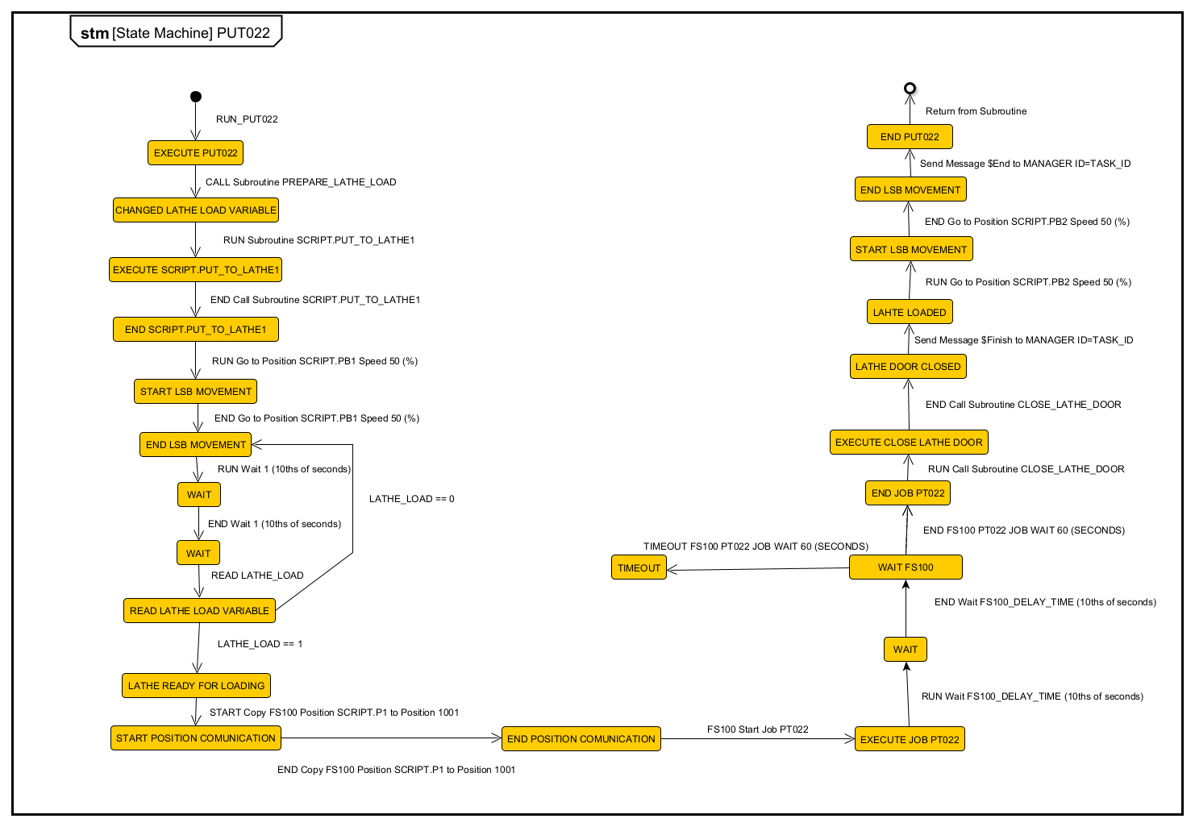

SUBROUTINE START_CYCLE_LATHE
Set Subroutine START_CYCLE_LATHE  Turn On Output O_LATHE_CYCLE_START  Wait 15 (10ths of seconds)  Turn Off Output O_LATHE_CYCLE_START  Print to Screen: WAIT_CYCLE_STARTED_LATHE  Wait Until Digital Input 15 is OFF ****** I_LATHE_CYCLE_IDLE  Run Subroutine WAIT_CYCLE_END_LATHE  Return from Subroutine | 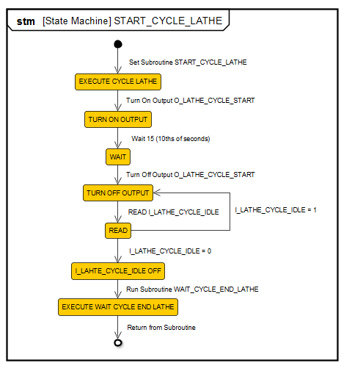

SUBROUTINE GET022
Set Subroutine GET022  Print to Screen: GET FROM LATHE (CONCEPT 250)  Run Subroutine PREPARE_LATHE_UNLOAD  Call Subroutine SCRIPT.GET_FROM_LATHE1  Print to Screen: P1,P2,P3, P4: 'SCRIPT.P1', 'SCRIPT.P2' , 'SCRIPT.P3' ,'SCRIPT.P4'  Print to Screen: PB1,PB2: 'SCRIPT.PB1', 'SCRIPT.PB2'  Go to Position SCRIPT.PB1 Speed 50 (%)  LATHE_READY_TO_UNLOAD:  Wait 1 (10ths of seconds)  If LATHE_UNLOAD ==0 Jump to LATHE_READY_TO_UNLOAD  Copy FS100 Position SCRIPT.P1 to Position 1001  Copy FS100 Position SCRIPT.P2 to Position 1002  Copy FS100 Position SCRIPT.P3 to Position 1003  Copy FS100 Position SCRIPT.P4 to Position 1004  FS100 Start Job GT022  Wait 10 (10ths of seconds)  FS100 Job Wait 60 (seconds)  Send Message $Start to MANAGER ID=TASK_ID  Return from Subroutine | 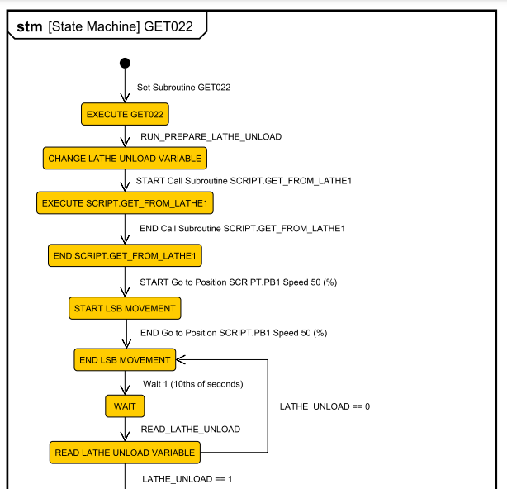  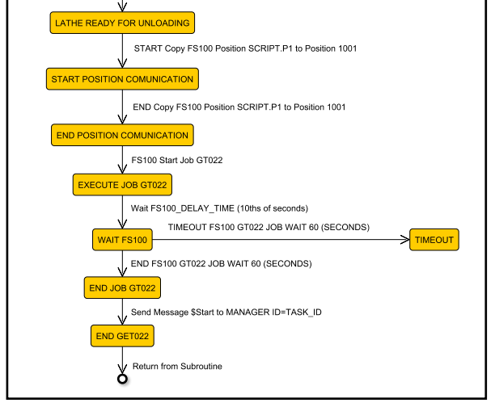

SUBROUTINE PUT025
Set Subroutine PUT025  Print to Screen: PUT TO RACK1  Call Subroutine SCRIPT.PUT_TO_RACK(1)  Set Variable PUT_RACK_NUMBER = 1  Call Subroutine PUT_RACK  Return from Subroutine | 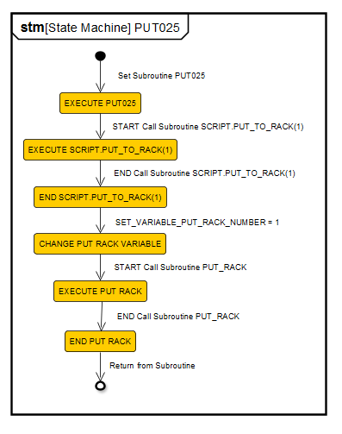

SUBROUTINE PREPARE_LATHE_LOAD
Set Subroutine PREPARE_LATHE_LOAD  Print to Screen: Prepare Lathe for Loading  Set Variable LATHE_LOAD = 1  Return from Subroutine | 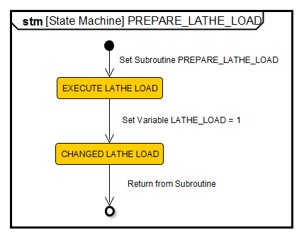

SUBROUTINE PREPARE_LATHE_UNLOAD
Set Subroutine PREPARE_LATHE_UNLOAD  Print to Screen: Prepare Lathe for Loading  Set Variable LATHE_UNLOAD = 1  Return from Subroutine | 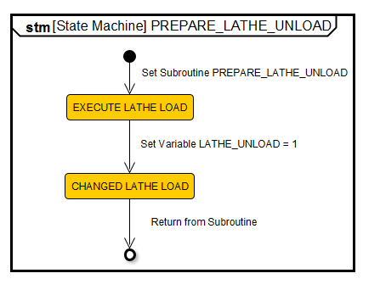

SUBROUTINE WAIT_CYCLE_END_LATHE
Set Subroutine WAIT_CYCLE_END_LATHE  Print to Screen: WAIT_CYCLE_END_LATHE  Wait Until Digital Input 15 is ON ****** I_LATHE_CYCLE_IDLE  Send Message ENDTURN to CNC Device Driver ID=22  Print to Screen: ENDTURN MESSAGE SEND  Return from Subroutine | 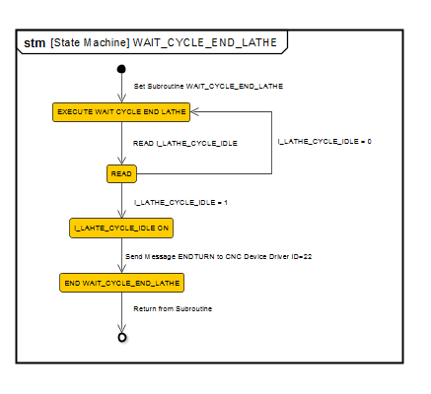

SUBROUTINE PUT_RACK
Set Subroutine PUT_RACK  Print to Screen: PUT TO Rack  Call Subroutine SCRIPT.PUT_TO_RACK(PUT_RACK_NUMBER)  Print to Screen: P1,P2,P3: 'SCRIPT.P1', 'SCRIPT.P2' , 'SCRIPT.P3'  Go to Position SCRIPT.PB1 Speed 50 (%)  Copy FS100 Position SCRIPT.P1 to Position 1001  Copy FS100 Position SCRIPT.P2 to Position 1002  Copy FS100 Position SCRIPT.P3 to Position 1003  FS100 Start Job PT-GENER  Wait 10 (10ths of seconds)  FS100 Job Wait 60 (seconds)  Send Message $Finish to MANAGER ID=TASK_ID  Send Message $End to MANAGER ID=TASK_ID  Return from Subroutine | 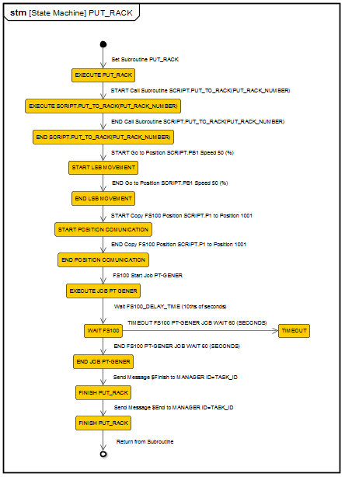

SUBROUTINE CLOSE_LATHE_DOOR
Set Subroutine CLOSE_LATHE_DOOR  Print to Screen: CLOSE DOOR OF LATHE  If Input 16 On Jump to DOOR_CLOSED. ***** I_LATHE_DOOR_CLOSED  Turn On Output O_LATHE_CDOOR  Wait 15 (10ths of seconds)  Turn Off Output O_LATHE_CDOOR  Wait Until Digital Input 16 is ON ***** I_LATHE_DOOR_CLOSED  DOOR_CLOSED:  Return from Subroutine | 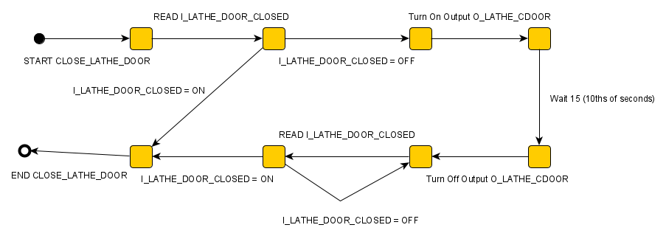

Variáveis de memória do Scorbase
SCORBASE VARIABLE LATHE_LOAD
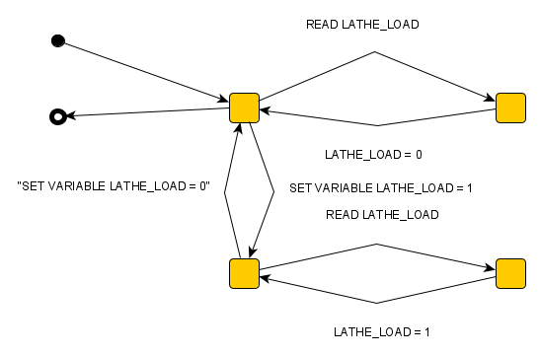

SCORBASE VARIABLE LATHE_UNLOAD
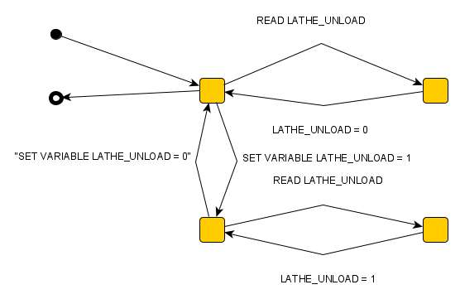

Jobs FS-100

/JOB  //NAME GT023  //POS  ///NPOS 0,0,0,5,0,0  ///TOOL 0  ///POSTYPE PULSE  ///PULSE  P00999=2214,-41185,-35222,-233,-81405,-53459  P01001=-29878,37538,-20693,-72,-35522,-36035  P01002=-29878,32662,-19317,-64,-40417,-36041  P01003=2214,-41185,-35222,-233,-81405,-53459  P01004=-95028,-41185,-35222,-233,-81405,-53459  //INST  ///DATE 2016/04/05 02:22  ///ATTR SC,RW  ///GROUP1 RB1  NOP  MOVJ P1004 VJ=30.00  MOVJ P1003 VJ=30.00  CALL JOB:OGRIP  WAIT IN#(1)=ON  MOVL P1001 V=50.0  TIMER T=1.000  CALL JOB:CGRIP  MOVL P1002 V=50.0  MOVJ P1004 VJ=30.00  MOVJ P0999 VJ=30.00  END | 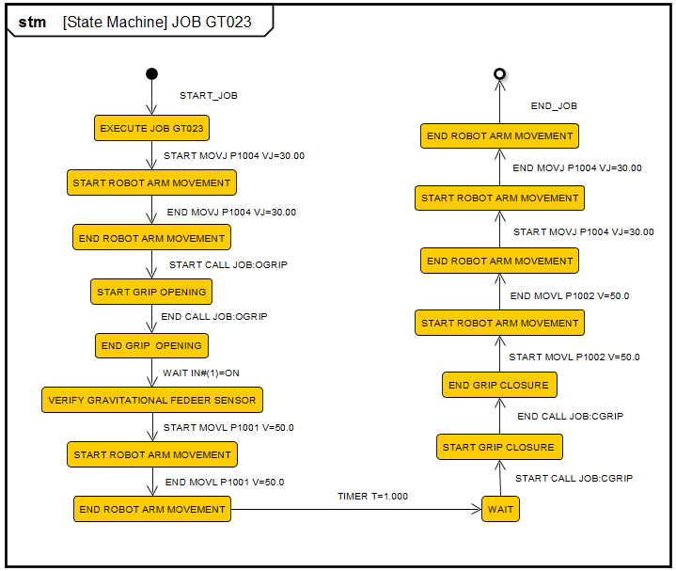

/JOB  //NAME PT022  //POS  ///NPOS 0,0,0,5,0,0  ///TOOL 0  ///POSTYPE PULSE  ///PULSE  P00999=2214,-41185,-35222,-233,-81405,-53459  P01001=-29878,37538,-20693,-72,-35522,-36035  P01002=-29878,32662,-19317,-64,-40417,-36041  P01003=2214,-41185,-35222,-233,-81405,-53459  P01004=-95028,-41185,-35222,-233,-81405,-53459  //INST  ///DATE 2016/04/02 04:48  ///ATTR SC,RW  ///GROUP1 RB1  NOP  MOVJ P0999 VJ=30.00  CALL JOB:L_ODOOR  CALL JOB:L_OCHUCK  MOVJ P1004 VJ=30.00  MOVJ P1003 VJ=30.00  MOVJ P1002 VJ=30.00  MOVL P1001 V=20.0  TIMER T=1.000  CALL JOB:L_CCHUCK  CALL JOB:OGRIP  MOVL P1002 V=50.0  MOVJ P1003 VJ=30.00  MOVJ P1004 VJ=30.00  MOVJ P0999 VJ=30.00  END | 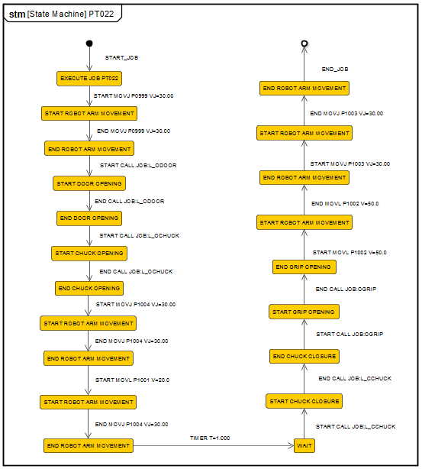

/JOB  //NAME GT022  //POS  ///NPOS 0,0,0,5,0,0  ///TOOL 0  ///POSTYPE PULSE  ///PULSE  P00999=2214,-41185,-35222,-233,-81405,-53459  P01001=-29878,37538,-20693,-72,-35522,-36035  P01002=-29878,32662,-19317,-64,-40417,-36041  P01003=2214,-41185,-35222,-233,-81405,-53459  P01004=-95028,-41185,-35222,-233,-81405,-53459  //INST  ///DATE 2006/10/05 10:00  ///ATTR SC,RW  ///GROUP1 RB1  NOP  MOVJ P0999 VJ=30.00  CALL JOB:L_ODOOR  MOVJ P1004 VJ=30.00  MOVJ P1003 VJ=30.00  CALL JOB:OGRIP  MOVJ P1002 VJ=30.00  MOVL P1001 V=50.0  TIMER T=1.000  CALL JOB:CGRIP  CALL JOB:L_OCHUCK  MOVL P1002 V=50.0  MOVJ P1003 VJ=30.00  MOVJ P1004 VJ=30.00  MOVJ P0999 VJ=30.00  END | 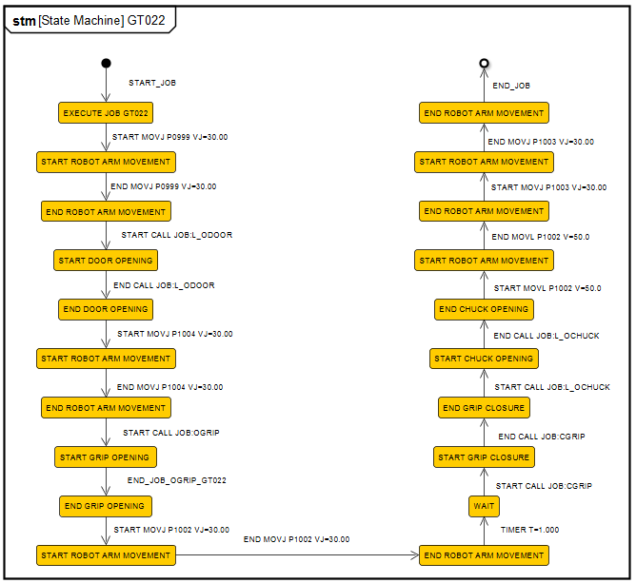

/JOB  //NAME PT-GENER  //POS  ///NPOS 0,0,0,3,0,0  ///TOOL 0  ///POSTYPE PULSE  ///PULSE  P01001=-29878,37538,-20693,-72,-35522,-36035  P01002=-29878,32662,-19317,-64,-40417,-36041  P01003=2214,-41185,-35222,-233,-81405,-53459  //INST  ///DATE 2008/02/28 22:00  ///ATTR SC,RW  ///GROUP1 RB1  NOP  JUMP *NO_ACCEL IF B011=0  MOVJ P1003 VJ=20.00 ACC=20 DEC=20  MOVJ P1002 VJ=20.00 ACC=20 DEC=20  MOVL P1001 V=100.0 ACC=20 DEC=20  SET B011 0  JUMP *DONE  *NO_ACCEL  MOVJ P1003 VJ=20.00  MOVJ P1002 VJ=20.00  MOVL P1001 V=100.0  *DONE  TIMER T=0.500  CALL JOB:OGRIP  MOVL P1002 V=100.0  MOVJ P1003 VJ=20.00  END | 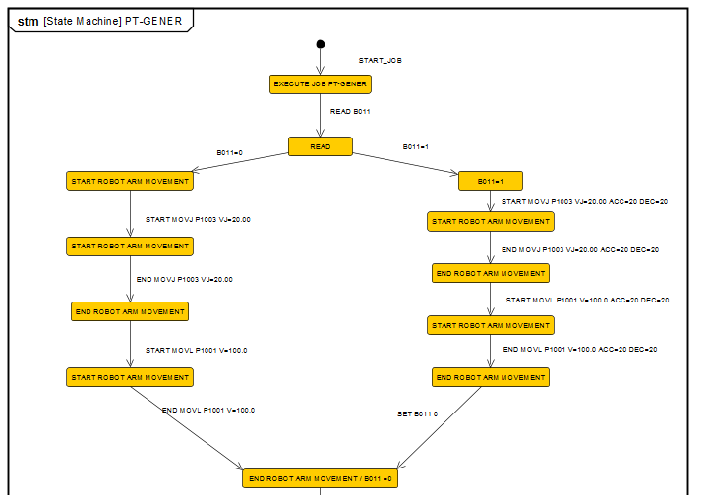  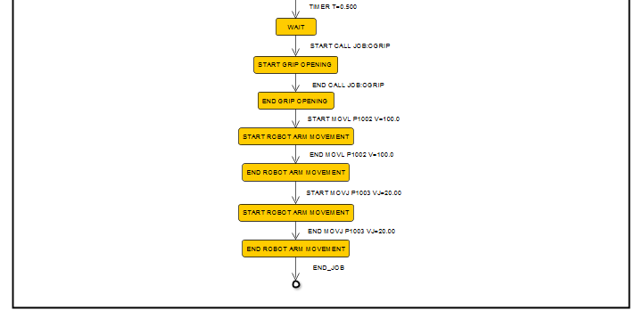

/JOB  //NAME OGRIP  //POS  ///NPOS 0,0,0,0,0,0  //INST  ///DATE 2014/05/29 06:10  ///ATTR SC,RW  ///GROUP1 RB1  NOP  DOUT OT#(1) ON  TIMER T=1.000  END | 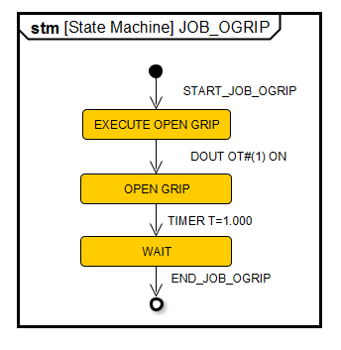

/JOB  //NAME CGRIP  //POS  ///NPOS 0,0,0,0,0,0  //INST  ///DATE 2014/05/29 06:10  ///ATTR SC,RW  ///GROUP1 RB1  NOP  DOUT OT#(1) OFF  TIMER T=1.000  END | 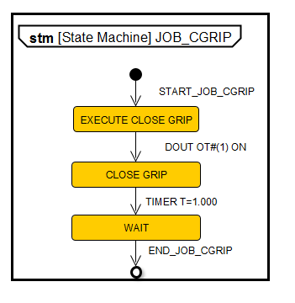

/JOB  //NAME L_OCHUCK  //POS  ///NPOS 0,0,0,0,0,0  //INST  ///DATE 2006/10/04 10:42  ///ATTR SC,RW  ///GROUP1 RB1  NOP  JUMP *COPEN IF IN#(11)=ON  PULSE OT#(11) T=1.000  WAIT IN#(11)=ON  *COPEN  END | 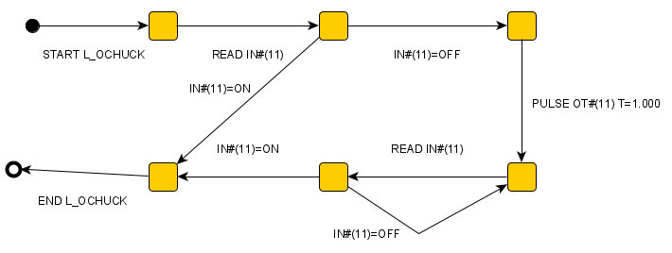

/JOB  //NAME L_CCHUCK  //POS  ///NPOS 0,0,0,0,0,0  //INST  ///DATE 2006/12/03 02:07  ///ATTR SC,RW  ///GROUP1 RB1  NOP  JUMP *CCLOSED IF IN#(12)=ON  PULSE OT#(12) T=1.000  WAIT IN#(12)=ON  *CCLOSED  END | 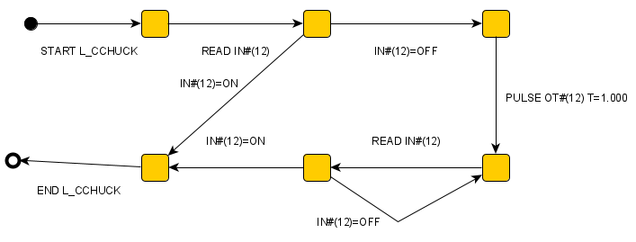

/JOB  //NAME L_ODOOR  //POS  ///NPOS 0,0,0,0,0,0  //INST  ///DATE 2006/10/04 10:42  ///ATTR SC,RW  ///GROUP1 RB1  NOP  JUMP *DOOROPEN IF IN#(9)=ON  PULSE OT#(9) T=1.000  WAIT IN#(9)=ON  *DOOROPEN  END | 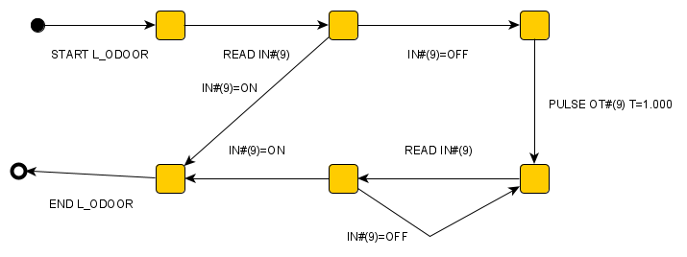

Variáveis de memória FS-100
FS-100 VARIABLE V011
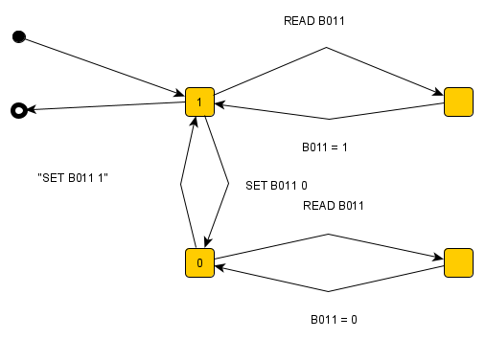

Componentes físicos
LATHE
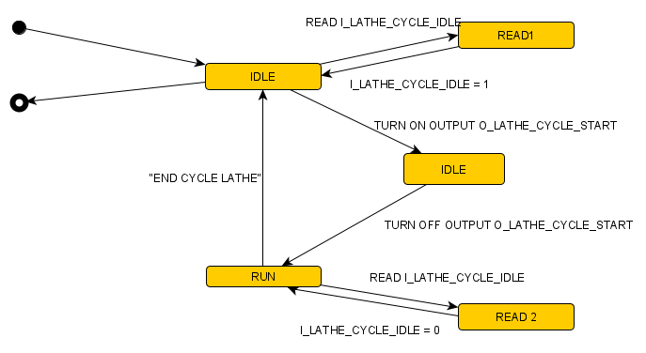

DOOR
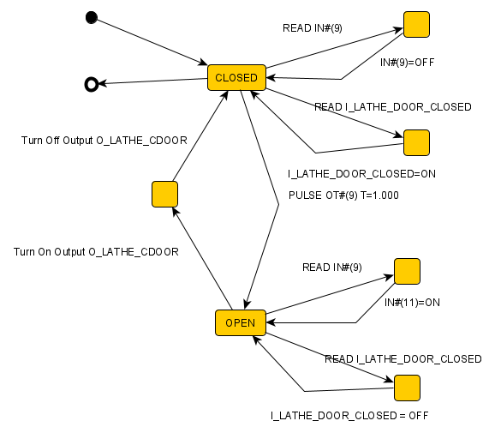

CHUCK
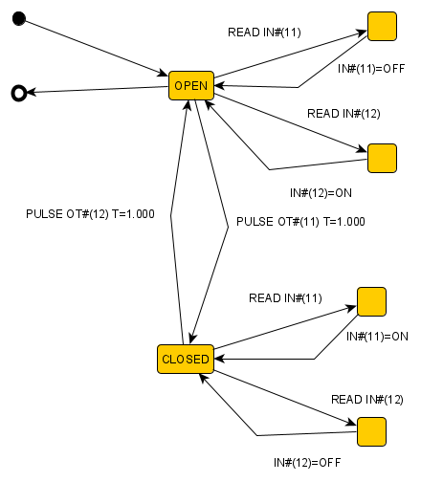

GRIP
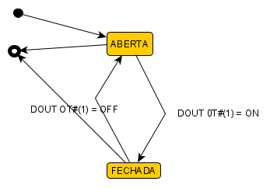

GFEEDER
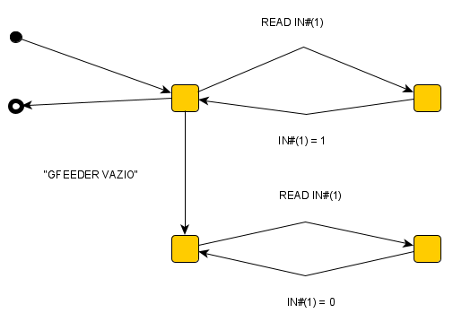

LSB
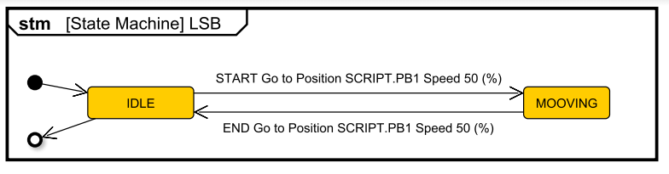

ARM SERVOS
START MOVJ P100X VJ=XX.XX  END MOVJ P100X VJ=XX.XX  START MOVL P100X V=XX.X  END MOVL P100X V=XX.X | 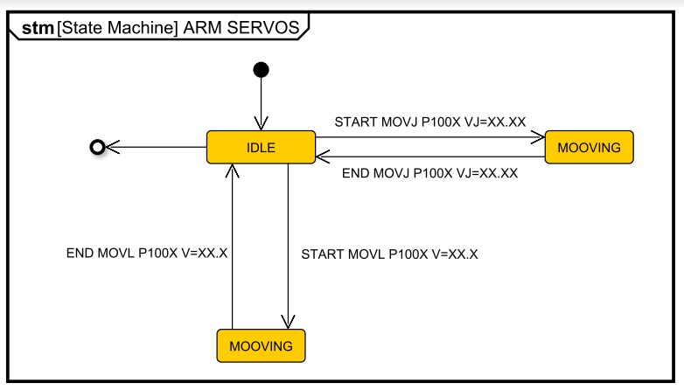

Executores / Processadores
VBASE SCRIPTS
START Call Subroutine SCRIPT.GET_FROM_GFDR1  END Call Subroutine SCRIPT.GET_FROM_GFDR1  START Run Subroutine PREPARE_LATHE_LOAD  END Run Subroutine PREPARE_LATHE_LOAD  START Call Subroutine SCRIPT.GET_FROM_LATHE1  END Call Subroutine SCRIPT.GET_FROM_LATHE1  START Call Subroutine SCRIPT.PUT_TO_RACK(1)  END Call Subroutine SCRIPT.PUT_TO_RACK(1)  START Call Subroutine SCRIPT.PUT_TO_RACK(PUT_RACK_NUMBER)  END Call Subroutine SCRIPT.PUT_TO_RACK(PUT_RACK_NUMBER) | 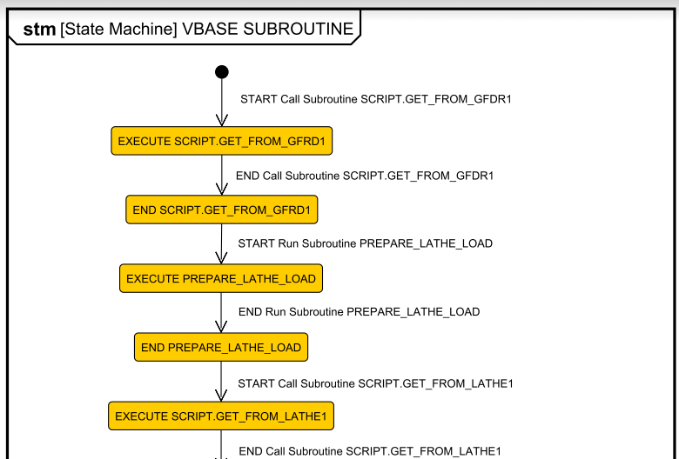
 | 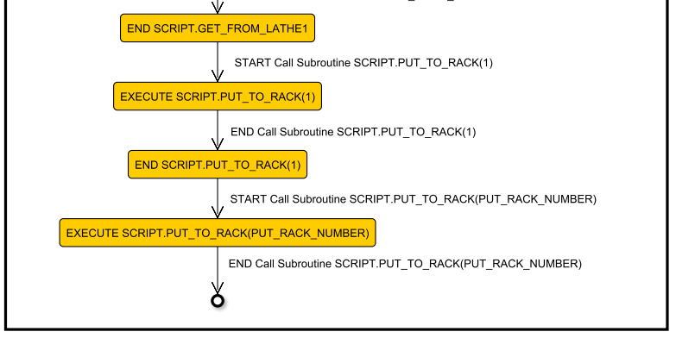

FS-100
START Copy FS100 Position SCRIPT.P1 to Position 1001  END Copy FS100 Position SCRIPT.P1 to Position 1001  FS100 Start Job GT023  FS100 End Job GT023  FS100 Timeout Job GT023  FS100 Start Job PT022  FS100 End Job PT022  FS100 Timeout Job PT022  FS100 Start Job GT022  FS100 End Job GT022  FS100 Timeout Job GT022  FS100 Start Job PT-GENER  FS100 End Job PT-GENER  FS100 Timeout Job PT-GENER | 